Fletcher Memorial Library Youth Activity Calendar |   February 2024

Sunday | Monday | Tuesday | Wednesday | Thursday | Friday | Saturday
 |  |  |  | 1 | 2 | 3

Lego Hangout
3:30-4:30
4 | 5 | 6 | 7 | 8 | 9 | 10
 |  | SAPCC Playgroup  10:30-12:00 | Story Time  10:30-11:15 | Drop In Crafts  3:00-4:30
11 | 12 | 13 | 14 | 15 | 16 | 17
 | Family PJ Story  Time  6:00-6:45 | SAPCC Playgroup  10:30-12:00 | Story Time  10:30-11:15  Valentine’s Day |  | Lego Hangout  3:30-4:30
18 | 19 | 20 | 21 | 22 | 23 | 24
TRSU School Vacation week |   CLOSED | SAPCC Playgroup  10:30-12:00 | Story Time  10:30-11:15 | Crafternoon  1:00-2:00pm | Movie Matinee-  1:00-3:00pm
25 | 26 | 27 | 28 | 29
 | Teen Jewelry Making  5:00-6:30pm | SAPCC Playgroup  10:30-12:00 | Story Time  10:30-11:15
 |  |  |  | 
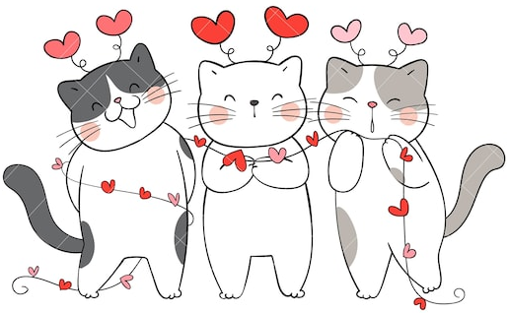
The odds of being born on February 29th are about 1 in 1,461. Those born on a leap day can be called a “leaper” or “leapling.
Fletcher Memorial Library
88 Main Street
Ludlow, Vermont 05149
802-228-3517

http://www.fmlnews.org
Email: FMLkidsVT@gmail.com

