

Fletcher Memorial Youth Library Activities February 1, 2024
Winter Story Time
Wednesdays
10:30am-11:15am
December 6, 2023 – March, 6, 2024
Best Suited for Ages 5 and Under
Story Time is a wonderful weekly routine to establish with your young child. Each week focuses on early literacy activities, stories, songs and ends with a craft or science exploration. It is a great opportunity for your child to socialize and meet new friends and for adult caregivers to connect.

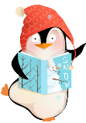
School Vacation Week
Activities
Monday- Closed for President’s Day

Tuesday- SAPCC Playgroup- 10:30-12:00- Ages Birth – 6- siblings welcome.

Wednesday- Story Time- 10:30-11:15- Best Suited for ages 5 and under

Thursday- Crafternoon- 1:00-2:00pm- DIY Crayon Creations! The library has A LOT of old crayons that are ready to begin a new life. Participants will create something new from something old and will make mini crayons to take home!

Friday-Movie Matinee- 1:00-3:00pm- Trolls Band Together (PG)
As Poppy (Anna Kendrick) grows closer to her now boyfriend Branch (Justin Timberlake), she discovers his secret past as a member of her favorite boyband, BroZone, with his four estranged brothers. When Branch's bro Floyd is kidnapped for his musical talents by a pair of nefarious popstars, Branch and Poppy embark on an action-packed journey to reunite the other brothers and rescue Floyd. Along the way Poppy uncovers a family secret of her own, a long-lost sister named Viva (Camila Cabello).

After School
Drop In Crafts
Thursday February 8, 2024
3:00-4:30
Valentine’s Love Bugs
Create cute, one of a kind Valentine Pompom love bugs to keep or share.

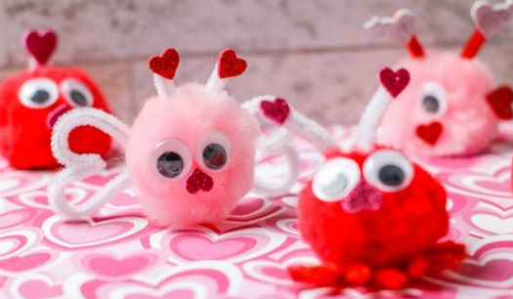
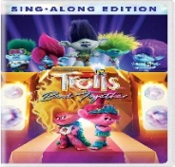

SAPCC Playgroup
Tuesday Mornings
10:30-12:00pm
Ages Birth-6 (Older
Siblings are Welcome to Attend)

Playgroups provides parents and children with opportunities to socialize, learn and have fun in a safe environment led by parent child center specialists.

Family Pajama Story Time
Monday February 12, 2024
6:00-6:45
Best Suited for ages 6 and under
The whole family is invited to don your comfy PJ’s and head over to the library of a evening of bedtime stories and gentle music.

Teen Jewerly Making (aka- Taylor Swift Braclets pt. 2)
Monday Febrary 26, 2024
5:00-6:30- Grades 6 & Up
Join us for a evening of fun jewerly making. We have all the supplies to make Taylor Swift Friendships bracelets, earringss, necklaces and more.
LEGO
Hangout

3:30-4:30 pm
Grades K & Up

Do you love to build with Legos? Join likeminded kids to free build or to work on a group project.

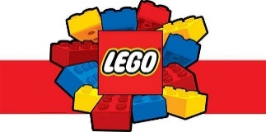
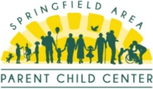
To register for programs call 228-3517, e-mail the youth library @ FMLkidsVT@gmail.com
Or visit fmlnews.org/youth.

